**How to fix Kodi issue due to (script) addons silently being disabled**See also <https://trac.kodi.tv/ticket/17652>  
  
Here’s the error when I was getting when I tried to start LiveStreamsPro video addon (below is with Kodi debugging enabled):  
  
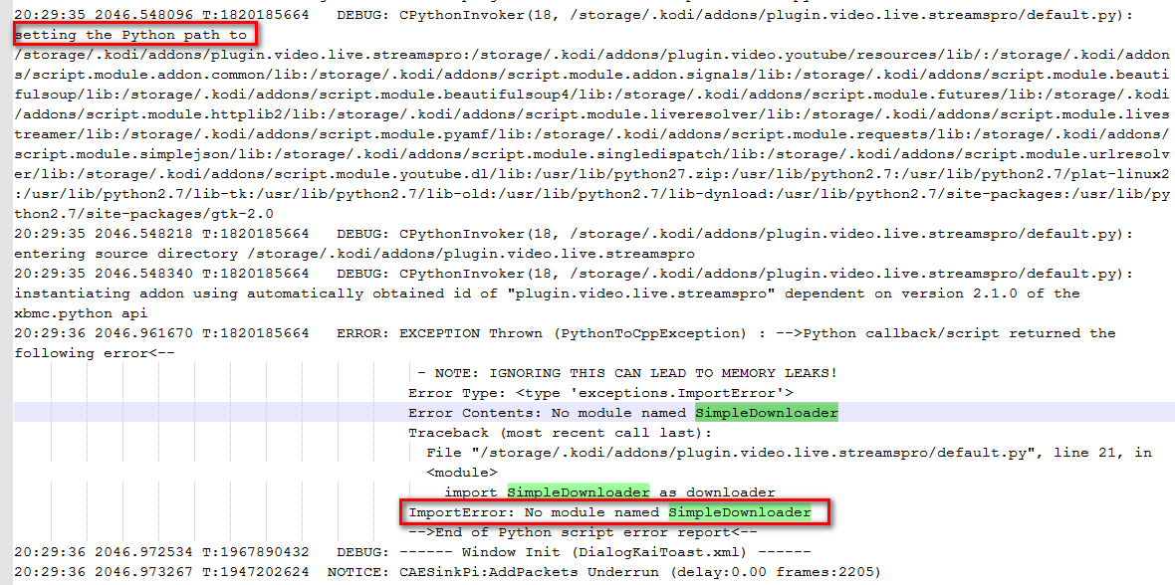  
  
This module “SimpleDownloader” is listed in the LiveStreamsPro addon.xml as a dependency. Apparently this should cause the python path to automatically include the location of the dependencies. However, the logging above clearly shows that the path to “SimplDownloader” was not added. After reading <https://trac.kodi.tv/ticket/17652>, it turns out this is because the addon had been disabled for some unknown reason:  
  
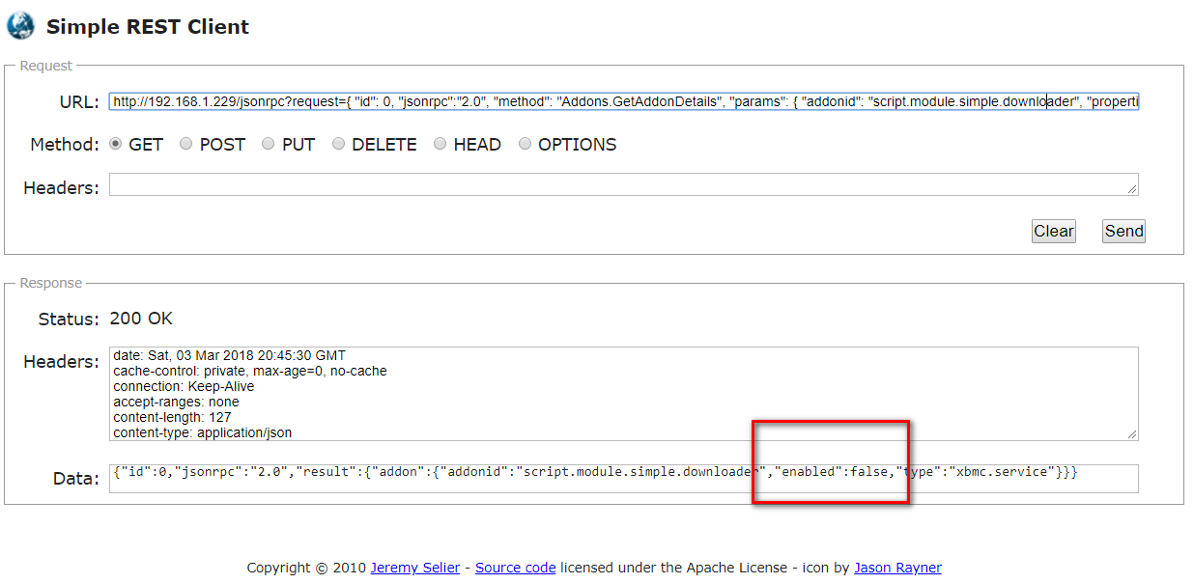  
  
To fix this, I used the RESET client to set the addon state to enabled:  
  
  
To change enabled state to true:   
  
http://192.168.1.229/jsonrpc?request={ "id": 0, "jsonrpc":"2.0", "method":"Addons.SetAddonEnabled","id":1,"params":{"addonid":"script.module.simple.downloader","enabled":true}}  
  
  
To check the enabled state:  
  
http://192.168.1.229/jsonrpc?request={ "id": 0, "jsonrpc":"2.0", "method": "Addons.GetAddonDetails", "params": { "addonid": "script.module.simple.downloader", "properties": ["enabled"] } }  
  
  
*JeremyC 03-03-2018***END**